Chapter 4, Problem 58.

The network in Fig. 4.124 models a bipolar transistor common-emitter amplifier connected to a load. Find the Thevenin resistance seen by the load.

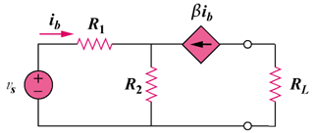

Figure 4.124
For Prob. 4.58.

